**How To Use**

You can access all the operations on this application by using Postman tool.

1: Run the application in Local. Which default gives you the list of Delivery Details available in DB.

URL to get the list of delivery details: <https://localhost:44334/api/TruckService>

2: Use the below URL to add delivery details.

URL to be used : <https://localhost:44334/api/TruckService/AddDeliveryDetails>

Sample JSON for request input :

{

“CustomerFirstName":"Vik",

"CustomerLastName":"LIn",

"CustomerMailId":"Vik.lin@test",

"Address":{

"Address1":"7920 Kirkfield Drr",

"City":"Nashville",

"State":"TN",

"Country":"USA",

"PostalCode":"37211"

}

}

3: Use the below URL to delete existing delivery details.

Url to be used : <https://localhost:44334/api/TruckService/DeleteDeliveryDetails>

Sample JSON for request input :

{

“CustomerFirstName":"Rishi",

"CustomerLastName":"Gun",

"CustomerMailId":"Rishi.gun@test.com",

"Address":{

"Address1":"1908 Flamingo dr",

"City":"Nashville",

"State":"TN",

"Country":"USA",

"PostalCode":"37211"

}

}

4: You can update customer name or address and based on the information provided, application will take care of what fields that need to be updated.

URL to be used : <https://localhost:44334/api/TruckService/UpdateDeliveryDetails>

{

“CustomerFirstName":"Det",

"CustomerLastName":"Labs",

"CustomerMailId":"Det.labs@test.com",

"Address":{

"Address1":"6915 Antioch Rd, main street",

"City":"Nashville",

"State":"TN",

"Country":"USA",

"PostalCode":"37211"

}

}

5: If you want experiment with validation that was implemented. Try to use the following Json

{

"CustomerFirstName":"Det",

"CustomerLastName":"",

"CustomerMailId":"Detroit.labs",

"Address":{

"Address1":"SomeWhere in detroit",

"City":"Detrot",

"State":"MI",

"Country":"USA",

"PostalCode":"05224"

}

}

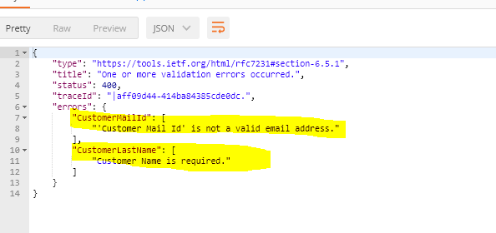

You wil see a validation error like above.